TITLE OF THE PROJECT

INTEGRATE ZSCALER WITH IDENTITY PROVIDERS(Isps) SUCH AS AZURE AD,OKTA, ACTIVE DIRECTORY FOR SEAMLESS AUTHENTICATION AND AUTHORIZATION.

LIST OF TEAMMATES:

S.no | Name | collage | contact
01 | Z YASEEN AHMED | Bishop Appasamy College Of  Arts and Science.  Coimbatore-641018 | zyaseenahmed@gmail.com  Mob.no:9944252813
02 | S SUJITH | Bishop Appasamy College Of  Arts and Science.  Coimbatore-641018 | Sujithbacas17@gmail.com  Mob.no: 8012681280
03 | S JOYALSAMSINGH | Bishop Appasamy College Of  Arts and Science.  Coimbatore-641018 | Joelsamsingh76@gmail.com  Mob.no:7904670244
04 | J SANTHOSHKUMAR | Bishop Appasamy College Of  Arts and Science.  Coimbatore-641018 | Santhos8438@gamil.com  Mob.no.8438862810
05 | P RITHIKGODSON | Bishop Appasamy College Of  Arts and Science.  Coimbatore-641018 | riorithik95@gmail.com  Mob.no.7339220973

PROJECT DETAILS:

TITLE: Integrate Zscaler with Identity Providers (IdPs) such as Azure AD, Okta, and Active Directory for seamless authentication and authorization.
INTRODUCTION:
The integration of Zscaler with Identity Providers (IdPs) such as Microsoft Entra ID, Okta, and on-premises Active Directory represents a significant advancement in modern enterprise security architecture. In traditional security models, organizations relied heavily on Virtual Private Networks (VPNs) and perimeter-based defenses to control access to applications and data. However, these approaches often resulted in excessive trust, limited visibility, and increased risks of unauthorized access or lateral movement within the network. As organizations adopt cloud services, remote work, and mobile access, there is a growing need for a more secure, scalable, and identity-driven approach to authentication and authorization.
This project focuses on implementing a seamless and secure integration between Zscaler and leading Identity Providers to establish a centralized identity management system. By leveraging this integration, users can authenticate once through their respective IdP and gain access to authorized applications without repeated logins, enabling a smooth Single Sign-On (SSO) experience. The authentication process is shifted from the traditional network layer to the application layer, ensuring that access decisions are based on user identity, device posture, and contextual factors rather than just network location. This approach aligns with the Zero Trust security model, where no user or device is trusted by default and every access request is continuously verified.
The integration supports widely adopted authentication and provisioning standards such as SAML (Security Assertion Markup Language), OpenID Connect (OIDC), and SCIM (System for Cross-domain Identity Management). These protocols enable secure communication between Zscaler and the Identity Providers, ensuring reliable authentication, authorization, and automated user lifecycle management. With automated provisioning, user accounts and group memberships are synchronized in real-time, reducing manual administrative effort and minimizing errors. Additionally, features such as Multi-Factor Authentication (MFA) and Conditional Access policies can be enforced through the IdPs, adding an extra layer of security during user authentication.
By integrating with Microsoft Entra ID, organizations can take advantage of advanced features such as Conditional Access, device compliance checks, and detailed reporting capabilities. Similarly, Okta provides a flexible and vendor-neutral platform with its Universal Directory and adaptive authentication features, enabling organizations to manage identities across multiple systems efficiently. For enterprises that continue to rely on on-premises infrastructure, Active Directory integration ensures that existing investments are preserved while extending secure access to cloud-based applications through Zscaler.
Overall, this integration enhances organizational security by centralizing authentication, simplifying user management, and providing consistent access control across different environments. It eliminates the need for multiple user directories and reduces dependency on legacy security models. By making identity the core component of access control, the solution enables organizations to achieve a robust Zero Trust framework, ensuring secure and seamless access to applications and resources in today’s dynamic digital environment.

ABSTRACT :
This project focuses on integrating Zscaler with enterprise Identity Providers (IdPs) such as Microsoft Entra ID, Okta, and on-premises Active Directory to enable secure, seamless authentication and authorization. Traditional security approaches based on VPNs and perimeter defenses often provide excessive access and lack flexibility, especially in modern cloud-driven environments. To address these limitations, this project adopts a Zero Trust architecture where user identity becomes the primary factor for granting access to applications and resources.
The integration enables Single Sign-On (SSO), allowing users to authenticate once and securely access multiple services without repeated logins. It leverages standard protocols such as SAML, OpenID Connect (OIDC), and SCIM to ensure secure communication, efficient authentication, and automated user provisioning. Through SCIM-based synchronization, user accounts and group memberships are updated in real time, reducing manual effort and minimizing errors in identity management. Additionally, advanced security features such as Multi-Factor Authentication (MFA) and Conditional Access policies are enforced through the connected IdPs, strengthening overall protection.
By utilizing Microsoft Entra ID, organizations can implement strict access controls based on device compliance, user risk levels, and location. Okta further enhances flexibility with its centralized identity management and adaptive authentication capabilities. For enterprises relying on traditional infrastructure, on-premises Active Directory integration ensures secure connectivity while preserving existing systems.
Overall, this project improves security posture, simplifies identity management, and enhances user experience by providing consistent and controlled access across platforms. By shifting from network-based security to identity-based access control, the solution enables organizations to implement an effective Zero Trust model and protect their digital resources in a scalable and efficient manner.

USE CASE SCENARIOS:

Use Case Scenario 1:
Remote Faculty Access to Research Data
A research professor is working from an off-campus conference and needs secure access to sensitive research data stored on an internal server. Instead of connecting to the full campus network via VPN, ZPA grants access only to the specific research server. The professor authenticates via the university's identity provider, and access is granted based on their role.

Output:
• User identity verified: Research_Faculty_Group
• Context-aware access enforced: Access allowed only from non-campus IP ranges
• Connection restricted: Limited to specific Research File Server (R&D_Server)
• Security enforcement: Multi-Factor Authentication (MFA) required due to off-network location
• No lateral movement: User cannot access other internal systems such as HR or student records

Use Case Scenario 2:
Student Access to Library Resources
A graduate student is off-campus and needs access to licensed academic journals and databases hosted internally. Instead of requiring a full VPN tunnel, ZPA provides direct access to the library application portal. The student authenticates via the identity provider, ensuring only enrolled students can access paid subscription content.

Output:
• User identity verified: Enrolled_Student_Group
• Access scope defined: Limited to Library Portal and journal databases
• Policy enforcement: Access restricted to authorized users only, preventing credential sharing
• User experience: Seamless SSO without additional VPN client complexity
• No broad network access: Student cannot navigate to administrative systems or internal servers .

Use Case Scenario 3:
HR Administrator Access to Payroll System
An HR administrator requires access to the payroll system to process monthly salaries. Access must be restricted to specific work hours and require step-up authentication due to the sensitivity of the data. The administrator authenticates via the identity provider, and ZPA enforces time based and MFA policies.

Output:
• User identity verified: HR_Payroll_Group
• Time-based restriction enforced: Access permitted only during business hours (8:00 AM – 6:00 PM)
• Step-up authentication: MFA triggered upon accessing the payroll application • Connection restricted: Limited to Payroll Application Server
• Audit trail: Full session logging maintained for compliance purposes
Use Case Scenario 4:
IT Helpdesk Remote Troubleshooting
An IT support technician needs to remotely troubleshoot a server issue while working from home. ZPA provides Just-in-Time (JIT) access to the specific server requiring maintenance. The technician authenticates via the identity provider, and administrative privileges are granted only for the duration of the task.

Output:
• User identity verified: IT_Helpdesk_Group
• Just-in-Time access granted: Admin rights elevated only for the active session • Connection restricted: Limited to the specific target server (Server-X)
• Privilege boundaries enforced: No access to other infrastructure components (databases, domain controllers)
• Session monitoring: Real-time activity logging for security review

Use Case Scenario 5:
Contractor Access to Project Management Tool
An external project manager contracted for a specific initiative needs access to the university's project management tool (e.g., Jira or SharePoint). Access must expire automatically upon contract completion. The contractor authenticates via the identity provider, and ZPA provisions time-limited access based on group membership synchronized from Azure AD.
Output:
• User identity verified: External_Contractor_Group
• Time-bound access policy enforced: Account deprovisioned automatically after contract end date
• Connection restricted: Limited to Project Management Application only
• Segmentation enforced: Contractor cannot discover or access internal resources like finance systems or student databases

Stage-1

TITLE: owasp top 10

OVERVIEW

The OWASP Top 10, published by the Open Worldwide Application Security Project (OWASP), is a globally recognized list that identifies the most critical security risks affecting web applications. It serves as a standard awareness document for developers, security professionals, and organizations to understand common vulnerabilities that attackers frequently exploit. The list is created using real-world data collected from thousands of applications and is updated periodically to reflect the evolving threat landscape. The OWASP Top 10 highlights major security issues such as broken access control, cryptographic failures, injection attacks, security misconfiguration, and server-side request forgery, which can lead to serious consequences including data breaches, unauthorized access, financial loss, and damage to an organization’s reputation. By following the OWASP Top 10 guidelines, organizations can improve their secure development practices, perform better security testing, and build more secure and reliable web applications.

LIST OF VULNERABILITY TABLE:

S.no | Vulnerability Name | CWE/CVE - No
1 | Improper Access Control | 284
2 | Cleartext Transmission of Sensitive Information | 319
3 | SQL Injection | 89
4 | Cleartext Storage of Sensitive Information | 312
5 | XML External Entity (XXE) | 611
6 | Use of Unmaintained Components | 1104
7 | Improper Authentication | 287
8 | Deserialization of Untrusted Data | 502
9 | Insufficient Logging | 778
10 | Server Side Request Forgery | 918

REPORT:
- Vulnerability Name: XML External Entity (XXE)
CWE/CVE: 611
OWASP/SANS Category: Broken Access Control
Description: Broken Access Control occurs when an application does not properly enforce restrictions on what authenticated users are allowed to do. Attackers can access other users’ data, modify records, or perform administrative actions.
Business Impact:
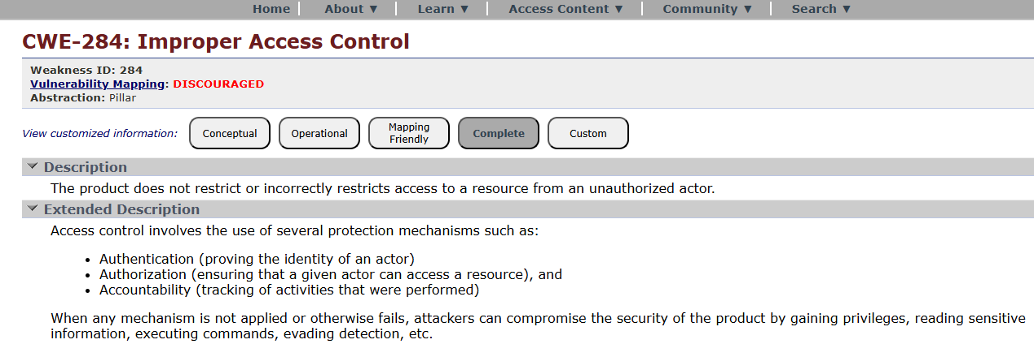

- Vulnerability Name: Cleartext Transmission of Sensitive Information
CWE/CVE: 284
OWASP/SANS Category: Cryptographic Failures
Description: Cryptographic failures occur when sensitive data such as passwords, credit cards, or personal information is not properly encrypted or protected.
Business Impact:
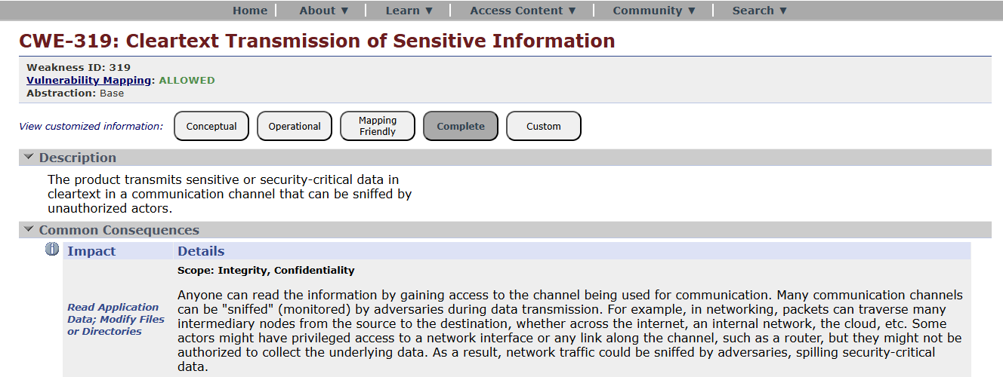

- Vulnerability Name: SQL Injection
CWE/CVE: 89
OWASP/SANS Category: Injection
Description: Injection flaws occur when untrusted user input is sent to an interpreter (SQL, OS commands, LDAP, etc.) without proper validation. Attackers can execute malicious commands.
Business Impact:
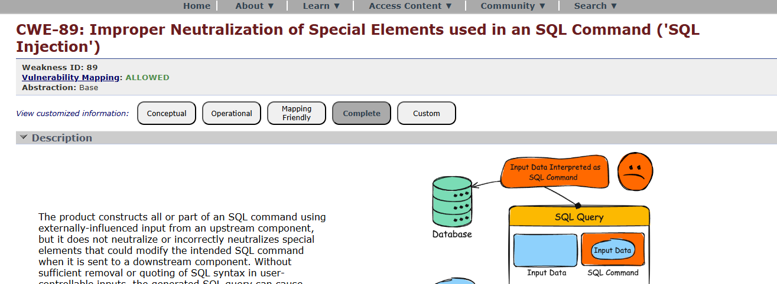

- Vulnerability Name: Cleartext Storage of Sensitive Information
CWE/CVE: 312
OWASP/SANS Category:
Insecure Design
Description:
Insecure design refers to flaws in system architecture or design that cannot be fixed simply by coding corrections.
Business Impact:
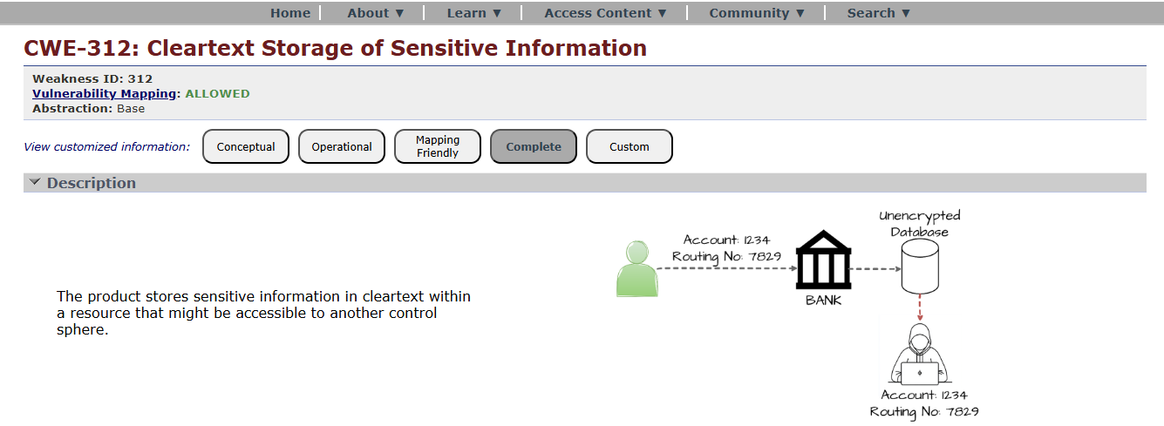

- Vulnerability Name: XML External Entity (XXE)
CWE/CVE: 611
OWASP/SANS Category:
Security Misconfiguration
Description:
Security misconfiguration occurs when security settings are incorrectly configured or left at default values.
Business Impact:
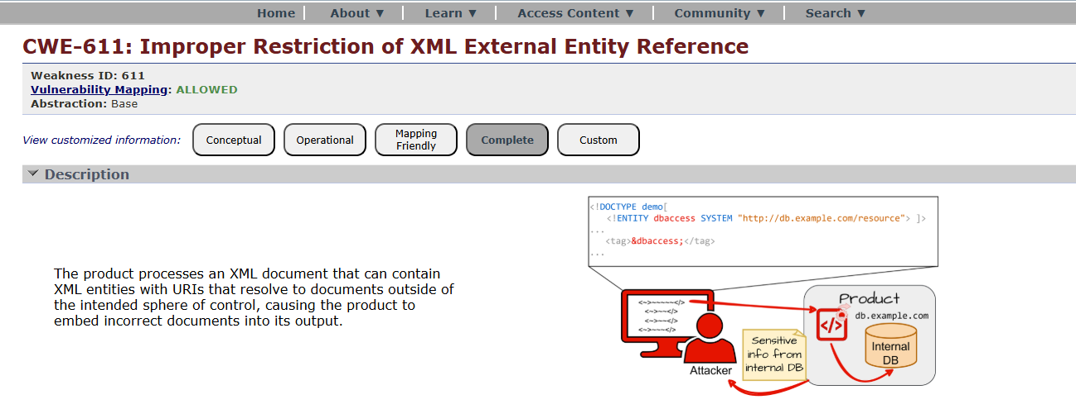

- Vulnerability Name: Use of Unmaintained Components
CWE/CVE: 1104
OWASP/SANS Category:
Vulnerable and Outdated Components
Description:
Applications may use libraries, frameworks, or software components with known vulnerabilities.
Business Impact:

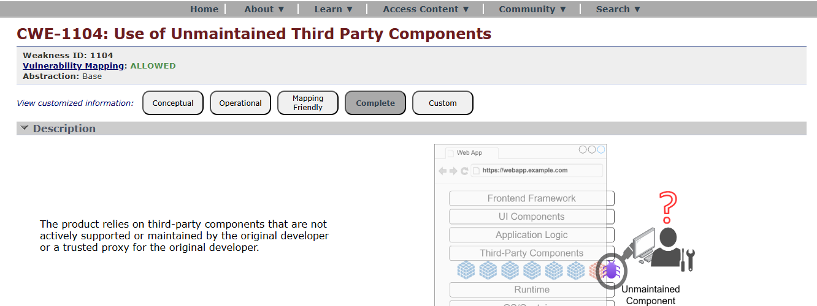

- Vulnerability Name: Improper Authentication
CWE/CVE: 287
OWASP/SANS Category:
Identification and Authentication Failures
Description:
Occurs when authentication mechanisms are poorly implemented.
Business Impact:
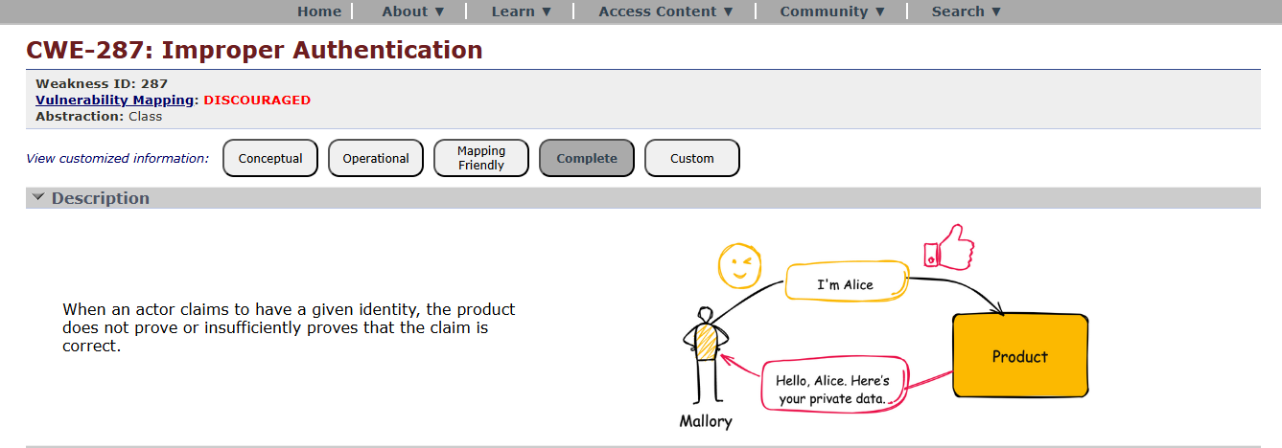

- Vulnerability Name: Deserialization of Untrusted Data
CWE/CVE: 502
OWASP/SANS Category:
Software and Data Integrity Failures
Description:
This vulnerability occurs when software updates or data are not verified for integrity.
Business Impact:
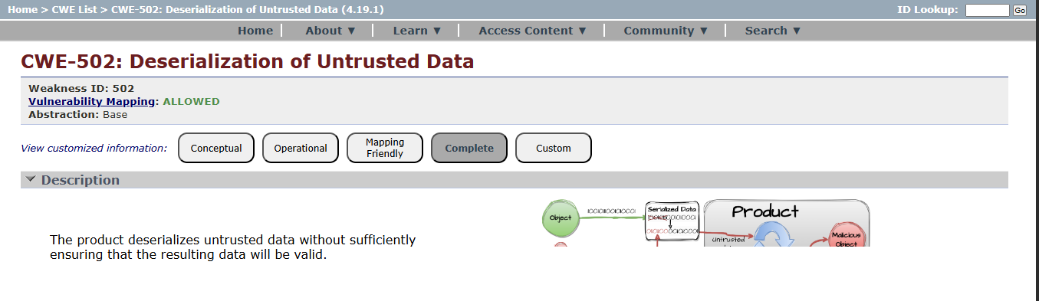

- Vulnerability Name: Insufficient Logging
CWE/CVE: 778
OWASP/SANS Category:
Security Logging and Monitoring Failures
Description:
Occurs when applications do not properly log security events or monitor suspicious activities.
Business Impact:
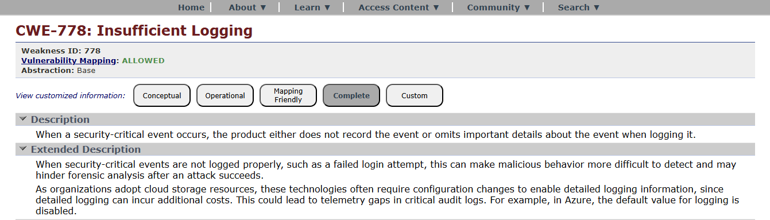

- Vulnerability Name: Server Side Request Forgery
CWE/CVE: 918
OWASP/SANS Category:
Server-Side Request Forgery (SSRF)
Description:
SSRF occurs when an attacker tricks the server into making requests to internal systems.
Business Impact:
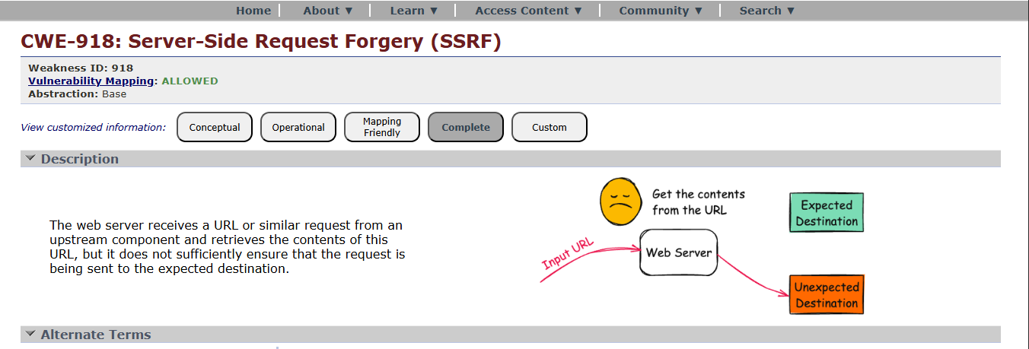

STAGE – 2
TITLE: Nessus Scanner
OVERVIEW:
Nessus scans are a critical component of proactive security, helping organizations identify and address vulnerabilities in their IT infrastructure to reduce the risk of security breaches and data compromises. The frequency and depth of scans can vary depending on an organization's security strategy and requirements.
Nessus is a popular vulnerability scanning tool used for identifying security weaknesses in computer systems and networks. It is widely utilized by security professionals and organizations to assess the security posture of their systems and to proactively identify potential vulnerabilities that could be exploited by attackers. Here's what I understand about Nessus scans:
Vulnerability Assessment:
Nessus performs a vulnerability assessment by scanning target systems or networks to identify security issues, such as missing patches, misconfigurations, weak passwords, and other potential weaknesses that could be exploited by attackers.
Network Scanning:
Nessus can scan a wide range of network devices, including servers, routers, switches, firewalls, and more. It examines network services, open ports, and software running on target systems.
Plugin Architecture:
Nessus uses a plugin-based architecture, allowing it to check for a wide variety of vulnerabilities. These plugins are regularly updated to include the latest security checks and support for new vulnerabilities.

Compliance Auditing:
It can also be used to assess systems against various compliance standards and regulatory requirements, helping organizations ensure that their systems meet specific security standards, like PCI DSS or CIS benchmarks.
Customization:
Nessus scans can be customized to suit the specific needs of an organization. Users can define scan policies, select the target systems, and specify the types of vulnerabilities to scan for.
Reporting:
Nessus provides detailed reports that highlight vulnerabilities, their severity, and remediation recommendations. These reports are essential for IT and security teams to prioritize and address vulnerabilities.
Scanning Frequency:
Organizations often perform regular Nessus scans to continuously monitor and improve their security posture. This is crucial for staying ahead of evolving threats and vulnerabilities.
Integration:
Nessus can be integrated with other security tools and platforms, allowing organizations to automate the scanning process and streamline their vulnerability management.
Licensing:
Nessus offers both free and commercial versions. The free version is limited in its functionality, while the commercial version provides more features and support.
User-Friendly Interface:
Nessus offers an easy-to-use web-based interface, making it accessible to a wide range of users, from security experts to less experienced IT professionals.

TARGET WEBSITE: zero.webappsecurity.com
TARGET IP ADDRESS: 54.82.22.214

LIST OF VULNERABILITY:

s.no | Vulnerability name | Severity | plugins
1 | SSL Version 2 and 3 Protocol Detection | CRITICAL | 20007
2 | TLS Version 1.0 Protocol Detection | MEDIUM | 104743
3 | JQuery 1.2 < 3.5.0 Multiple XSS | MEDIUM | 136929
4 | SSL DROWN Attack Vulnerability (Decrypting RSA with Obsolete and Weakened eNcryption) | MEDIUM | 89058
5 | OpenSSL SSL_OP_NETSCAPE_REUSE_CIPHER_CHANGE_BUG Session Resume Ciphersuite D | MEDIUM | 51892
6 | Nessus SYN scanner | INFO | 11219
7 | Service Detection | INFO | 22964
8 | JQuery Detection | INFO | 106658
9 | Additional DNS Hostnames | INFO | 46180
10 | Shor's Harvest Now Decrypt Later | INFO | 298387

REPORT:
1) Vulnerability Name: - SSL Version 2 and 3 Protocol Detection
Severity: - CRITICAL
Plugin: - 20007
Port: - Hosts
Description: -
The remote service accepts connections encrypted using SSL 2.0 and SSL 3.0 protocols. These protocols are outdated and contain multiple cryptographic weaknesses that make them insecure for modern communication.
SSL 2.0 suffers from serious design flaws, including weak message authentication and lack of protection against Man-in-the-Middle (MITM) attacks. SSL 3.0 is vulnerable to attacks such as the POODLE (Padding Oracle on Downgraded Legacy Encryption) attack, which allows attackers to decrypt sensitive information.
Modern systems and browsers no longer support SSL 2.0 and SSL 3.0 due to these vulnerabilities. Instead, newer versions such as TLS 1.2 and TLS 1.3 provide stronger encryption and protection against known threats.
As per industry standards and security best practices, including PCI DSS requirements, SSL 2.0 and SSL 3.0 must be completely disabled. Systems continuing to support these protocols are at high risk of data exposure, session hijacking, and unauthorized access.
SOLUTION: -
Consult the application's documentation to disable SSL 2.0 and 3.0.
Use TLS 1.2 (with approved cipher suites) or higher instead.
IMPACT: -
Continued use of SSL 2.0 and SSL 3.0 protocols, known for their inherent cryptographic weaknesses, exposes the organization to severe security risks, significantly increasing the likelihood of data breaches and cyberattacks. These outdated protocols are vulnerable to exploits such as Man-in-the-Middle (MITM) attacks and the POODLE attack, enabling attackers to intercept and decrypt sensitive communications.
This vulnerability compromises the confidentiality and integrity of critical data, including user credentials, financial information, and session details. It also results in non-compliance with industry standards and regulations, including PCI DSS, which strictly prohibits the use of insecure SSL protocols. Non-compliance may lead to regulatory penalties, legal consequences, and loss of business credibility

2) Vulnerability Name: - TLS Version 1.0 Protocol Detection
Severity: - MEDIUM
Plugin: - 104743
Port: - Hosts
Description: -
The remote service accepts connections encrypted using TLS 1.0 protocol. TLS 1.0 contains several known cryptographic design weaknesses that make it less secure compared to modern encryption standards.
Although some implementations attempt to mitigate these flaws, TLS 1.0 remains vulnerable to various attacks due to outdated cipher suites and weaker security mechanisms. Newer versions such as TLS 1.2 and TLS 1.3 are specifically designed to address these issues and provide stronger encryption and improved security.
As of March 31, 2020, major web browsers and vendors have deprecated support for TLS 1.0. Additionally, industry compliance standards such as PCI DSS v3.2 mandate the complete disabling of TLS 1.0 to ensure secure data transmission.
Systems that continue to support TLS 1.0 are considered insecure and may expose sensitive data to potential threats.
SOLUTION: -
Enable support for TLS 1.2 and 1.3, and disable support for TLS 1.0.
IMPACT: -
Continued use of TLS 1.0, despite its known cryptographic weaknesses, exposes the organization to increased security risks and potential cyberattacks. Attackers may exploit these vulnerabilities to intercept communications, perform Man-in-the-Middle (MITM) attacks, and compromise sensitive data.
This vulnerability affects the confidentiality and integrity of transmitted information, including login credentials and personal data. It also leads to non-compliance with security standards such as PCI DSS v3.2, which requires disabling TLS 1.0. Failure to comply may result in regulatory penalties, legal risks, and loss of customer trust.
Furthermore, modern browsers and vendors no longer support TLS 1.0, leading to compatibility issues, service disruptions, and degraded user experience. This can negatively impact business operations, reduce customer satisfaction, and harm the organization’s reputation.
Addressing this vulnerability is essential to ensure secure communication, maintain compliance, and protect against evolving cybersecurity threats.

3) Vulnerability Name: - JQuery 1.2 < 3.5.0 Multiple XSS
Severity: - MEDIUM
Plugin: - 136929
Port: - Hosts
Description: -
The remote web application is using a version of jQuery between 1.2 and 3.5.0, which contains multiple known Cross-Site Scripting (XSS) vulnerabilities. These vulnerabilities arise due to improper handling and sanitization of user-supplied input within certain jQuery functions.
Attackers can exploit these flaws by injecting malicious scripts into web pages that are executed in the browsers of other users. This can occur through manipulated inputs in functions such as html (), append (), or other DOM manipulation methods that do not adequately filter untrusted data.
Updated versions of jQuery (3.5.0 and above) include fixes that properly sanitize inputs and mitigate these vulnerabilities. Systems using outdated versions remain exposed to XSS attacks and associated risks.
SOLUTION: - Upgrade to JQuery version 3.5.0 or later.
IMPACT: -
Continued use of jQuery versions 1.2 to 3.5.0, which contain known Cross-Site Scripting (XSS) vulnerabilities, exposes the application to significant security risks, increasing the likelihood of client-side attacks and data compromise. These vulnerabilities allow attackers to inject malicious scripts into web pages, which are then executed in the browsers of unsuspecting users.
This can lead to the theft of sensitive information such as user credentials, session cookies, and personal data, ultimately resulting in unauthorized access and session hijacking. The integrity of the web application may also be compromised through content manipulation or redirection to malicious websites.
Furthermore, the presence of such vulnerabilities may result in non-compliance with security standards and best practices, potentially leading to regulatory concerns and loss of customer trust. Exploitation of XSS vulnerabilities can damage the organization’s reputation and negatively impact user confidence.
Addressing this vulnerability is essential to prevent script injection attacks, protect user data, and ensure a secure and trustworthy web application environment.

4) Vulnerability Name: - SSL DROWN Attack Vulnerability (Decrypting RSA with Obsolete and Weakened eNcryption)
Severity: - MEDIUM
Plugin: - 89058
Port: - Hosts
Description: - The remote service is vulnerable to the DROWN (Decrypting RSA with Obsolete and Weakened eNcryption) attack, which exploits the use of outdated and insecure SSLv2 protocol to compromise modern TLS connections. Even if the server primarily uses secure protocols like TLS, the presence of SSLv2 support on the same server or a related system can allow attackers to decrypt encrypted traffic.
The DROWN attack takes advantage of weaknesses in SSLv2 to perform cryptographic attacks against RSA-encrypted sessions, potentially exposing sensitive data. Systems that share the same private key across multiple services are particularly at risk.
Modern security practices require disabling SSLv2 entirely and ensuring that secure protocols such as TLS 1.2 and TLS 1.3 are used to prevent such attacks.
SOLUTION: - Disable SSLv2 and export grade cryptography cipher suites. Ensure that private keys are not used anywhere with server software that supports SSLv2 connections.
IMPACT: - The presence of the DROWN vulnerability exposes the organization to serious security risks by enabling attackers to decrypt secure communications, significantly increasing the likelihood of data breaches and cyberattacks. By exploiting weaknesses in SSLv2, attackers can compromise the confidentiality of data transmitted over otherwise secure TLS connections.
This can lead to exposure of sensitive information such as login credentials, financial data, and private communications, resulting in unauthorized access and potential misuse of critical systems. The vulnerability undermines trust in encrypted connections and compromises the overall security posture of the organization.
Furthermore, this issue may lead to non-compliance with industry security standards and best practices, potentially resulting in regulatory penalties and reputational damage. Systems vulnerable to DROWN may also face compatibility and trust issues with modern clients and services.
Addressing this vulnerability is essential to eliminate weak encryption pathways, protect sensitive data, and ensure a secure and compliant communication environment.

5) Vulnerability Name: - OpenSSL SSL_OP_NETSCAPE_REUSE_CIPHER_CHANGE_BUG Session Resume Ciphersuite D
Severity: - MEDIUM
Plugin: - 51892
Port: - Hosts
Description: -The remote service is affected by a vulnerability related to the OpenSSL SSL_OP_NETSCAPE_REUSE_CIPHER_CHANGE_BUG option, which impacts how session resumption is handled in SSL/TLS connections. This issue arises when the server improperly reuses cipher suite parameters during session renegotiation or resumption.
Due to this flaw, the server may allow the reuse of previously established session settings without properly validating the security parameters, potentially leading to weaker encryption being applied. This behavior can result in inconsistent or insecure cryptographic operations during secure communications.
Modern versions of OpenSSL have addressed this issue, and secure configurations recommend disabling insecure options and ensuring proper session handling mechanisms. Systems using outdated or misconfigured OpenSSL implementations remain vulnerable.
SOLUTION: - Upgrade to OpenSSL 0.9.8q / 1.0.0.c or later, or contact your vendor for a patch
IMPACT: Continued use of vulnerable OpenSSL configurations involving the SSL_OP_NETSCAPE_REUSE_CIPHER_CHANGE_BUG option exposes the system to security risks by weakening the integrity of SSL/TLS session management. Improper handling of session resumption may allow attackers to exploit inconsistencies in cipher suite negotiation.
This can potentially lead to reduced encryption strength, making it easier for attackers to intercept or manipulate encrypted communications. In certain scenarios, it may increase the risk of Man-in-the-Middle (MITM) attacks, compromising the confidentiality and integrity of sensitive data.
The presence of this vulnerability may also result in non-compliance with modern security standards and best practices, increasing the risk of regulatory issues and loss of customer trust. Additionally, it can weaken the overall security posture of the system by introducing flaws in secure session handling.
Addressing this vulnerability is essential to ensure proper SSL/TLS configuration, maintain strong encryption standards, and protect against potential exploitation.

6) Vulnerability Name: Nessus SYN scanner
Severity: - INFO
Plugin: - 11219
Port: - Hosts
Description: -The Nessus SYN Scanner plugin indicates that a SYN scan was performed to identify open ports on the target system. A SYN scan, also known as a half-open scan, sends TCP SYN packets to the target and analyzes the responses to determine which ports are open, closed, or filtered without completing the full TCP handshake.
This is a standard network discovery and reconnaissance technique used by security tools to map exposed services and assess the attack surface of a system. It does not represent a vulnerability itself but provides valuable information about accessible network services.
The results of this scan help in identifying potential entry points that may be exploited if associated services are misconfigured or vulnerable.
SOLUTION: Protect your target with an IP filter.
IMPACT: The Nessus SYN Scanner finding is informational in nature and does not directly indicate a security weakness. However, it highlights the presence of open ports and accessible services, which can increase the system’s exposure to potential attacks if not properly secured.
Open ports may allow attackers to identify running services and attempt further exploitation, especially if those services contain vulnerabilities or weak configurations. This increases the overall attack surface and may aid in reconnaissance activities by malicious actors.
Additionally, unnecessary or unused open ports can lead to security risks if they are not monitored or protected by appropriate security controls such as firewalls and access restrictions.
Addressing this finding involves reviewing open ports, disabling unnecessary services, and ensuring that all exposed services are securely configured and regularly updated to minimize potential risks.

7) Vulnerability Name: Service Detection
Severity: - INFO
Plugin: - 22964
Port: - Hosts
Description: -The Service Detection plugin identifies the services running on open ports of the target system. It analyzes responses from the system to determine the type of service, application, and sometimes the version information associated with each open port.
This process helps in mapping the network environment by providing insights into exposed services such as web servers, database servers, and other network applications. It is a standard reconnaissance technique used during vulnerability assessments to understand the system’s attack surface.
This finding is informational and does not indicate a direct vulnerability, but it provides essential details that can be used to identify potential security weaknesses in detected services.
SOLUTION: Disable unnecessary services, update active ones, and restrict exposure using firewalls while minimizing service information disclosure.
IMPACT: The Service Detection finding is informational in nature and does not directly represent a security vulnerability. However, it reveals details about running services and their versions, which can be valuable information for attackers during reconnaissance.
By identifying active services, attackers may target specific applications with known vulnerabilities, increasing the likelihood of successful exploitation. Exposure of service details can also aid in fingerprinting the system and planning more advanced attacks.
Additionally, unnecessary or outdated services discovered through this process may introduce security risks if they are not properly secured, configured, or updated.
Addressing this finding involves reviewing detected services, minimizing exposure by disabling unused services, and ensuring that all active services are securely configured, regularly updated, and protected by appropriate security controls.

8) Vulnerability Name: JQuery Detection
Severity: - INFO
Plugin: - 106658
Port: - Hosts
Description: -The jQuery Detection plugin identifies the presence of the jQuery library in the target web application and may also determine its version. This helps in understanding whether the application is using a supported or outdated version of jQuery.
This finding is informational and does not indicate a direct vulnerability. However, detecting the use of jQuery, especially older versions, can help identify potential exposure to known security issues such as Cross-Site Scripting (XSS) vulnerabilities.
The information gathered through this detection is commonly used during security assessments to evaluate the security posture of client-side libraries and dependencies.
SOLUTION: Ensure jQuery is updated to the latest secure version and avoid exposing its version details to minimize potential security risks.
IMPACT: The jQuery Detection finding is informational in nature and does not directly represent a security vulnerability. However, it reveals the use of a client-side library, which may be leveraged by attackers to identify potential weaknesses if outdated or vulnerable versions are in use.
If the detected jQuery version is outdated, it may expose the application to known vulnerabilities such as XSS attacks, increasing the risk of data compromise and unauthorized actions. This can affect the security of user data and the integrity of the web application.
Additionally, disclosure of technology stack details can aid attackers in reconnaissance and targeted exploitation. This may increase the overall attack surface and risk profile of the application.
Addressing this finding involves ensuring that jQuery is up to date, minimizing exposure of version details, and regularly reviewing third-party libraries for known vulnerabilities.

9) Vulnerability Name: Additional DNS Hostnames
Severity: - INFO
Plugin: - 46180
Port: - Hosts
Description: -The Additional DNS Hostnames plugin identifies extra hostnames and domain names associated with the target system through DNS resolution. This includes aliases, subdomains, or alternate names that point to the same IP address.
This finding is informational and does not indicate a direct vulnerability. However, it helps in discovering additional assets and entry points that may be part of the organization’s infrastructure.
Such information is commonly gathered during reconnaissance to build a more complete picture of the target environment and identify potentially overlooked or less-secured systems.
SOLUTION: Review and secure all identified hostnames, removing unused entries and ensuring proper configuration and monitoring of active domains.
IMPACT: The Additional DNS Hostnames finding is informational in nature and does not directly represent a security vulnerability. However, it reveals additional hostnames and subdomains that may expand the visible attack surface of the organization.
Attackers can use this information to identify hidden or less-monitored systems and target them for exploitation, especially if they are misconfigured or not regularly updated. This increases the risk of unauthorized access and potential security breaches.
Additionally, unmanaged or forgotten subdomains may host outdated applications or services, further increasing exposure to vulnerabilities and attacks.
Addressing this finding involves reviewing all discovered hostnames, ensuring they are properly secured, actively managed, and removing or disabling any unused or unnecessary entries.

10) Vulnerability Name: Shor's Harvest Now Decrypt Later
Severity: - INFO
Plugin: - 298387
Port: - Hosts
Description: -The Shor's Harvest Now Decrypt Later finding indicates that the target system is using cryptographic algorithms (such as RSA or ECC) that may become vulnerable in the future due to advances in quantum computing. This concept refers to attackers collecting and storing encrypted data today with the intention of decrypting it later when quantum computing capabilities become powerful enough.
Current encryption methods are considered secure against classical computers, but future quantum algorithms, such as Shor’s algorithm, could potentially break widely used public-key cryptosystems. This makes long-term sensitive data particularly at risk.
This finding is informational and highlights a potential future risk rather than an immediate vulnerability.
SOLUTION: Adopt quantum-resistant cryptographic algorithms and update encryption strategies to prepare for future quantum computing threats.
IMPACT: The Harvest Now, Decrypt Later scenario poses a long-term security risk, where sensitive encrypted data intercepted today may be decrypted in the future using quantum computing techniques. This can compromise the confidentiality of critical information such as personal data, financial records, and confidential communications.
Although there is no immediate threat, organizations handling long-lived sensitive data may face future data exposure if quantum-resistant cryptographic measures are not adopted. This can impact data privacy, regulatory compliance, and overall trust in the organization’s security practices.
Additionally, failure to prepare for post-quantum cryptography may result in delayed response to emerging threats, increasing the risk of future exploitation and reputational damage.
Addressing this concern involves planning for quantum-resistant (post-quantum) cryptographic algorithms, strengthening encryption strategies, and staying aligned with evolving security standards.

STAGE – 3
TITLE:
Integrate Zscaler with Identity Providers (IdPs) such as Azure AD, Okta, and Active Directory for seamless authentication and authorization.

OVERVIEW :
In response to the evolving threat landscape and the dissolution of the traditional network perimeter, modern enterprises are rapidly shifting away from legacy VPN-centric remote access models. These conventional approaches often grant excessive network-level access, creating a significant attack surface and increasing the risk of lateral threat movement. To address these challenges, this project centers on the implementation of a Zero Trust security architecture, fundamentally operating on the principle of "never trust, always verify." By moving beyond location-based access, we aim to establish a security posture where trust is no longer implicit, and access is determined by granular context rather than network connectivity.
The core of this initiative involves the deployment of Zscaler Private Access (ZPA), a cloud-delivered Zero Trust Access solution designed to create identity-aware, application-specific connectivity. Unlike traditional VPNs that place users on the internal network, ZPA leverages a "service-initiated" model to establish direct, one-to-one connections between authorized users and specific applications, completely hiding the corporate network and IP address space from the internet. This ensures that users connect exclusively to the applications they are permitted to access, based on continuous identity verification and context, rendering the applications invisible to unauthorized users and preventing common attack vectors such as port scanning and distributed denial-of-service (DDoS) attacks.
Ultimately, this project will enforce a least-privilege access model, ensuring users and devices are granted the minimum required access necessary to perform their functions. By decoupling application access from network access, we will eliminate the risk of lateral movement across the network, as users have no visibility or connectivity to other hosts. This strategic move not only significantly enhances security by reducing the attack surface but also simplifies the user experience and reduces operational overhead associated with legacy remote access infrastructure, positioning the organization at the forefront of secure and efficient access management.

CONTEXT-AWARE ACCESS CONTROL:
Context-aware access controls represent the operational pinnacle of a Zero Trust architecture, moving beyond static rules to create a dynamic and adaptive security perimeter around every application. In a modern enterprise, where users are mobile, devices are diverse, and threats are sophisticated, granting access based solely on a username and password is a dangerous oversimplification. Designing and applying context-aware controls means building a policy engine that consumes multiple, real-time signals about an access request and renders an intelligent decision: to allow, to block, to limit, or to challenge. This approach ensures that the security posture is not a flat, always-on gate but a responsive system that tightens or loosens based on the risk of the specific moment.

USER IDENTITY:
The design of such a system begins with a deep integration between the access broker, such as Zscaler Private Access (ZPA), and the organization's existing security and identity infrastructure. The first and most fundamental layer is user identity. This is not simply a username, but a rich set of attributes pulled from the corporate Identity Provider (IdP) like Azure AD or Okta. Integration via SAML ensures that when a user authenticates through the ZPA client, they are verified with multi-factor authentication (MFA) by the IdP. ZPA then ingests not just the user's name, but their group memberships (e.g., "Finance – Payroll Managers," "Engineering – Source Code Contributors"), roles, and department. This allows for the creation of granular policies that are intrinsically tied to the user's function within the organization. For instance, a policy can be written in plain language: "Allow members of the 'Finance-Payroll' group to access the 'ADP Payroll' application."
DEVICE POSTURE:
However, a valid identity on a compromised device is still a critical threat. This is where the second layer, device posture, becomes essential. The design incorporates continuous checks on the security health of the endpoint attempting the connection. Through integrations with Endpoint Detection and Response (EDR) tools like CrowdStrike or SentinelOne, and Mobile Device Management (MDM) solutions like JAMF or Intune, ZPA can assess a device's real-time hygiene. The policy engine evaluates factors such as: Is the device's disk encryption (BitLocker/FileVault) enabled? Is the antivirus software active and its definition database up-to-date? Has the operating system been patched to the latest security baseline? Is the device rooted or jailbroken? Is there a high-risk score being reported by the EDR tool due to suspicious activity? If a device fails these checks—for example, a user's laptop has its firewall disabled—the context-aware policy can automatically trigger an action. It might block access entirely, or it might grant "remediation access," routing the user to a captive portal to download updates or contact IT, while preventing them from reaching any business-critical applications. This ensures that a vulnerable endpoint cannot become a beachhead for an attacker to move laterally into the corporate environment.
LOCATION:
The third contextual layer is location and network environment. The physical or virtual location from which a user connects provides a powerful signal for risk assessment. A finance director accessing the payroll system from their home office in the same city is a low-risk event. The same user attempting to connect from a country with a high prevalence of cybercrime, or from an anonymizing VPN service, should be treated with extreme suspicion. Context-aware policies can be designed to enforce this logic. For example, access to a source code repository containing intellectual property could be restricted to users connecting from a corporate office or a pre-approved home IP address range. If a legitimate user is traveling, the policy might allow access but require a step-up authentication, such as a hardware token, or grant only read-only permissions. This layer can also consider the security of the network itself; a connection from a public, unencrypted Wi-Fi hotspot might trigger stricter controls than one from a known, secure corporate network.
APPLICATION RISK:
The final and often most strategic layer is application risk. Not all applications are created equal, and their access policies should reflect their value and sensitivity. In the design phase, applications are categorized and tagged based on their risk profile. An internal wiki used for cafeteria menus would be classified as low-risk, whereas a customer database, a financial trading platform, or a source code repository would be classified as high or critical risk. This tagging allows policies to be layered and dynamic. A single user might have access to multiple applications, but the controls applied to each session will differ based on the application's risk. For the low-risk wiki, a valid user identity and a compliant device might be sufficient. However, for the high-risk financial platform, the policy engine might require all four layers to align: the user must be in a specific group, on a fully patched and managed device, connecting from a trusted location, and may even be subject to session recording or time-of-day restrictions. This ensures that security resources and scrutiny are applied proportionally to the actual risk, preventing "blanket" access and ensuring that the most valuable assets have the most robust defenses.

CONCLUSION:

STAGE – 1:
In conclusion, web application testing is a crucial process that ensures the security, functionality, and reliability of web-based software. It involves a comprehensive evaluation of various aspects, including user interface, functionality, performance, and security to identify and rectify issues before they impact end-users. This process not only enhances the quality of web applications but also bolsters their resilience against potential threats and vulnerabilities. In an age where online services and applications are integral to our daily lives, effective web application testing is essential to deliver a seamless and secure user experience.

STAGE – 2:
The Nessus report for the specific website has highlighted key security insights. It identified vulnerabilities, categorized by severity, with a focus on critical and high-risk issues that need immediate attention. Recommendations for addressing these vulnerabilities include patching, reconfiguration, and other security measures, with a priority on actions that can have the most significant impact. Compliance with industry standards and best practices is considered, ensuring alignment with recognized security benchmarks like OWASP guidelines. The report underscores the need for continuous monitoring, regular updates, and ongoing security efforts to maintain a strong security posture. In summary, the Nessus report offers a clear view of the website's security state, provides guidance on mitigating vulnerabilities, and stresses the importance of sustained vigilance against evolving threats.

STAGE – 3:
The implementation of Zscaler Private Access marks a pivotal shift from a vulnerable, network-centric security model to a resilient, identity-centric Zero Trust architecture. By enforcing least-privilege access and rendering private applications invisible to the internet, this project effectively neutralizes the threats of lateral movement and network-based attacks. The solution not only fortifies the organization's security posture against modern cyber threats but also delivers a seamless and high-performance experience for a distributed workforce. Furthermore, the decoupling of access from the network simplifies IT operations, reduces dependency on legacy VPN infrastructure, and provides granular visibility into user-application interactions. Ultimately, this initiative establishes a future-ready foundation for secure digital transformation.

FUTURE SCOPE:
STAGE – 1: Future scope of web application testing
The future scope of web application testing is promising and evolving rapidly, driven by the continuous growth of the internet and web-based applications.
Here are some key aspects of its future scope:
▪ Increased Demand: As more businesses and services move online, the demand for web applications continues to grow. This, in turn, increases the demand for web application testing to ensure security, reliability, and functionality.
▪ Advanced Technologies: The complexity of web applications is rising with the integration of advanced technologies like AI, IoT, and blockchain. Testing these cutting-edge applications will require specialized skills and tools.
▪ Security Emphasis: With the growing number of cyber threats and data breaches, security testing for web applications will become even more critical. Testers will need to focus on vulnerabilities, data protection, and compliance with regulations like GDPR.
▪ Mobile and Cross-Browser Testing: Mobile usage is on the rise, and web applications must be responsive and functional on various devices and browsers. Testing for cross-compatibility will be essential.
▪ Performance Testing: As user expectations for speed and performance increase, load testing, stress testing, and other performance testing types will be crucial to ensure web applications can handle traffic spikes.

STAGE – 2: Future scope of the testing process you understood.
The future scope of the web application testing process, particularly in terms of identifying vulnerabilities, is exceedingly promising due to the continuous growth of digital platforms, the escalating importance of cybersecurity, and the ever-evolving threat landscape. Here are some key aspects that highlight the prospective scope of web application testing for vulnerability discovery:
▪ AI-Driven Testing: The integration of artificial intelligence (AI) and machine learning (ML) into web application testing tools will revolutionize the way vulnerabilities are identified. AI algorithms can swiftly scan vast amounts of code and data to pinpoint vulnerabilities that might elude human testers.
▪ IoT and Mobile App Testing: With the proliferation of Internet of Things (IoT) devices and the increasing usage of mobile applications, the scope of web application testing will extend to encompass these areas. Ensuring the security of IoT devices and the interfaces they use will become critical.
▪ Blockchain and Cryptocurrency Security: As blockchain technology and cryptocurrencies continue to gain traction, security testing will be imperative to safeguard transactions and digital assets. Ensuring the robustness of blockchain-based applications will be a specialized niche in web application testing. Serverless Architectures: With the adoption of serverless computing, web application testing will need to adapt to assess the security of serverless functions and APIs. Ensuring that serverless components are free from vulnerabilities will be paramount.
▪ Container Security: As containerization technologies like Docker and Kubernetes become ubiquitous, web application testing will extend to cover container security. This includes ensuring that container images and orchestration configurations are free from vulnerabilities.

STAGE – 3: Future scope of Aware Access Control
The successful deployment of ZPA lays the groundwork for a broader, more integrated security ecosystem. Future enhancements can be explored to further mature the organization's security capabilities:
▪ Integration with Zscaler Internet Access (ZIA): Converging Private Access (ZPA) with Internet Access (ZIA) to create a unified Secure Access Service Edge (SASE) platform, managing all web and private traffic through a single policy framework.
▪ Advanced Device Posture Checking: Moving beyond basic compliance to incorporate real-time risk scores from EDR tools, blocking access if a device shows signs of active compromise.
▪ Privileged Remote Access: Extending ZPA to third-party vendors and contractors with time-bound, audited access to specific critical systems, replacing jump boxes and bastion hosts.
▪ IoT/OT Segmentation: Applying the same micro-tunneling principles to Internet of Things (IoT) and Operational Technology (OT) devices to ensure they can only communicate with specific management servers.
▪ AI-Driven Anomaly Detection: Leveraging machine learning on ZPA logs to detect behavioral anomalies, such as a user accessing an application at an unusual hour or from a strange location, triggering automated MFA challenges or access revocation.
▪ Cloud Workload Protection: Utilizing ZPA to secure connections between containers and microservices in multi-cloud environments (AWS, Azure, GCP), ensuring east-west traffic between workloads is encrypted and authenticated.
▪ Automated Provisioning/Deprovisioning: Enhancing the identity provider integration to automatically revoke application access the moment an employee is terminated or changes roles, ensuring near real-time access control.
▪ Digital Experience Monitoring (DEM): Implementing DEM tools to proactively monitor the end-user experience, identifying network latency or application performance issues before they impact productivity.

TOPICS EXPLORED: owasp top 10, scanning, vulnerabilities, application risk, access control, awareness, user identity, location.
TOOLS EXPLORED: Zscaler, owasp, Nessus, zero.webappsecurity.com.

THE END

